Programming FundamentalsLab 2 Submission
Name [ Irfan Ahmad]
Roll No. [ 02 ]
Program [Computer Science]
Section [ C ]
Submitted To [ Sir Asad sahib ]
Date [11-10-2026]

Handwritten
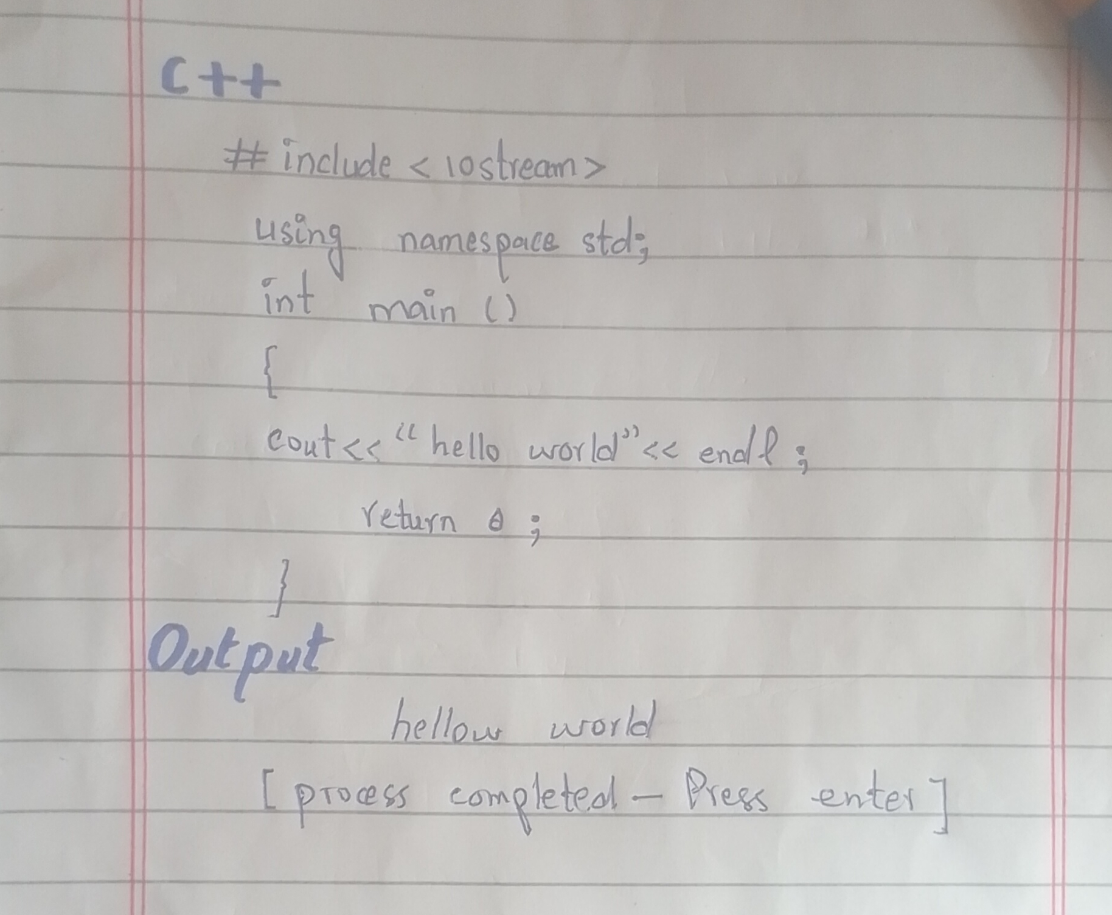
Screenshot
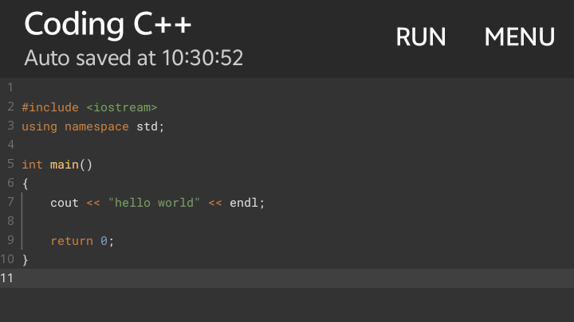
Result
